Hennepin County

Family Response and Stabilization Services (FRSS)   
Interviewer Manual



# TABLE OF CONTENTS

Evaluation overview 4

Confidentiality 4

Protecting the rights of evaluation participants 4

Complying with the Health Insurance Portability and Accountability Act (HIPAA) 5

Protecting confidentiality and privacy 6

Scheduling interviews 7

Receiving an invitation to conduct an interview 7

Scheduling the interview with the family 8

Conducting the interview 9

Establishing rapport with respondents 9

Honoring informed consent 11

Following the interview format 11

Controlling the interview process 11

Supporting participants during the interview 12

Conducting effective interviews 14

Recording interview responses 18

Closing the interview 18

Reviewing interview package for completeness 18

Completing and/or providing applicable forms 18

Thanking respondents 18

Reviewing interview materials 18

Making annotations 19

Submitting materials to the Community Research Solutions 19

Payment for interviewers 20

Supervision and coordination of evaluation team members 20

Coordination between interviewers and the lead evaluators 20

Coordination among all evaluation staff 21

Attachment 1: Sample confidentiality agreement 22

Attachment 2: Suggested responses for handling respondent concerns 25

Attachment 3: Interviewer supplies 27

Attachment 4: Skype instructions 29

Attachment 5: Procedure for making emergency disclosures of confidential information 35

Attachment 6: Procedure for making disclosures of confidential information due to risk/threat of harm 36

Attachment 7: Procedure for filing grievances about services 38

# Evaluation overview

Hennepin County is implementing Family Response and Stabilization Services (FRSS) to provide immediate and in-person support to children and families experiencing mental, behavioral, or emotional issues. Family Response (FR) is an up-to-72-hour intervention to de-escalate the situation and address any immediate concerns. If families need longer-term intervention, they may be referred for optional Stabilization Services (SS), which is an up-to-8-week intervention to promote building a family support network and the healthy, safe behaviors of the children involved.

Families drive the experience – they define their goals and staff work with each family to navigate how to achieve those goals. Stabilization services are delivered by community organizations which are culturally-responsive to groups that have typically been underserved, specifically Somali and Spanish-speaking communities. Services are available free of charge and available to all families with children ages 5-18 who reside in Hennepin County.

Hennepin County has secured a 4-year federal grant to implement FRSS services. A required component of the grant is to conduct discharge interviews with families as they complete Stabilization Services. Program staff anticipate approximately 80-160 family discharges from Stabilization Services during each year of the grant.

Interviewers will be responsible for contacting each family, scheduling and conducting the discharge interview, and submitting interview data to the evaluators. To continue serving families in as culturally-responsive manner as possible, interviewers will, to the extent possible, be matched with families who share their cultural background. As the program serves any family who resides in Hennepin County, this may not always be possible and interviewers may be asked to interview families from a diverse array of cultural communities.

Interviews should be conducted within one week of the family discharge from Stabilization Services. They may be conducted in-person, virtually, or via phone call. Following completion of each interview, you will submit the data gathered to Community Research Solutions. You will be paid a stipend for each interview completed and submitted, as well as mileage traveled for in-person interviews. You will also receive a stipend for required training and meetings.

# Confidentiality

In any evaluation or research project, it is important to protect the rights of participants. For the FRSS evaluation, a wide array of personal information about participants will be collected, such as issues related to mental health and stress. Given the nature of these data, it is especially important to maintain high standards regarding issues such as confidentiality. In this section, we outline the main procedures that we will use to protect the rights of participants, and outline the procedures that will be followed if we feel that rights to confidentiality should be violated.

## 

## Protecting the rights of evaluation participants

Participants in any type of research project, including evaluation, have specific rights established at the Federal level. The Belmont Report, published in 1979, outlines basic ethical principles and their application to research in relation to the “rights of human subjects.” Application of these ethical principles includes informed consent, assessment of risks and benefits associated with study participation, and appropriate selection of participants. Participant rights, addressed through informed consent, include study information, protection from harm, voluntary participation, and freedom to make participation choice without threat of consequences. All staff involved with the FRSS evaluation are expected to maintain the highest standards related to the protection of participant rights. All evaluation team members will receive training and will be expected to comply with all evaluation procedures related to human subjects protection. As a condition of their involvement, all evaluation team members will be required to sign a confidentiality agreement (Attachment 1).

## Complying with the Health Insurance Portability and Accountability Act (HIPAA)

The Health Insurance Portability and Accountability Act of 1998 (HIPAA) was enacted by Congress in an effort to protect the privacy and confidentiality of private health information. In general, the health and mental health services provided through FRSS are covered under HIPAA, meaning that high standards are in place to protect the rights of the youth and families who receive services. Similarly, all information about youth and families that is obtained through the evaluation activities must be collected, stored, and protected in accordance with this law. This manual outlines implications of HIPAA of most relevance to this evaluation. It is not meant to be a comprehensive description of HIPAA policies or procedures.

While there are multiple components of HIPAA, the greatest implications for this evaluation project can be found in the Act’s Privacy Rule. The Privacy Rule establishes federal safeguards to protect the confidentiality of medical information, such as the mental health information collected in this evaluation. In general, the Privacy Rule requires that we:

* Provide information to participants about their privacy rights and how their information can be used;
* Adopt clear privacy procedures for the evaluation project;
* Train employees and contractors so that they understand the privacy procedures; and
* Limit access to evaluation information containing Individually Identifiable Health Information so that they are not readily available to those who do not need them.

### 

### Consequences of non-compliance

To ensure that all parties realize the degree of seriousness that is attached to the disclosure of the protected information, the Privacy Rule contains penalties for non-compliance and illegal disclosure. An individual who fails to comply with the Act can face civil penalties of $100 per violation, up to $25,000 per person, per year for each requirement violated. The penalties are higher for individuals who intentionally obtain or disclose protected information in an illegal way. For these disclosures, an individual can face:

* **Federal criminal penalties** of up to $50,000 and one year in prison for improperly obtaining or disclosing protected information
* **Federal criminal penalties** of up to $100,000 and up to five years in prison for obtaining or disclosing protected information under ‘false pretenses’
* And, **federal criminal penalties** of up to $250,000 and up to 10 years in prison for obtaining or disclosing protected information with the intent to sell, transfer or use it for commercial advantage, personal gain, or malicious harm

Policies and safeguards have been established to ensure that all staff involved in the evaluation will comply with HIPAA.

###### Protected Health Information (PHI)

HIPAA regulations define health information as “any information, whether oral or recorded in any form or medium” that:

* Is created or received by a health care provider, health plan, public health authority, employer, life insurer, school or university, or health care clearinghouse; or
* Relates to the past, present, or future physical or mental health or condition of an individual; the provision of health care to an individual; or the past, present, or future payment for the provision of health care to an individual.

**Protected health information (PHI)** refers to individually identifiable health information. Identifiable information refers not only to data that are explicitly linked to a particular individual, but also includes data items which reasonably could be expected to allow identification. For example, in some communities or types of data, someone might reasonably be able to guess the identity of a research participant, even if that person’s name or other identifying information was not included. For the FRSS evaluation, the following information is considered to be PHI:

* Information obtained through interviews about health or mental health status, including the results of mental health assessments
* Information about health or mental health services received gathered during research activities (note: even satisfaction surveys are considered to be PHI if they identify a specific individual as having received health or mental health services)
* Information orally communicated to interviewers related to health or mental health (including information about health or mental health services received)

Even if details about mental health status are not provided, simply being identified as having received services is protected information. Therefore, any material that lists people who are participating in the evaluation would also be considered to be PHI.

## Protecting confidentiality and privacy

### 

### Basic operating principles

It is important to remember that all information you collect is completely confidential. The following procedures will be enacted across the evaluation team to ensure that we maintain confidentiality and are fully compliant with the expectations of HIPAA. First, all evaluation team members are expected to protect the confidentiality and privacy of our participants by adhering to the following guidelines:

* Never talk about the participants to anyone outside the project.
* Never recount “amusing anecdotes” about participants, even if the participants are not identified by name in the story – someone listening in may be able to identify the respondent just based on the story.
* If you print materials that contain protected health information (PHI), promptly retrieve those materials from the printer to ensure that others who share that printer do not see them.
* Do not leave PHI in areas in which other people can read them.
* Store all PHI in locked cabinets when they not being used, including overnight.

### Considerations for in-person interviews

During interviews, you will obtain a wide range of confidential information from parents. It will be important to keep this information confidential. If interviews with parents are conducted in-person (i.e., in their homes or other community settings), additional safeguards must be put into place to ensure that their information is kept secure. The following procedures will be followed by all evaluation staff who conduct interviews:

* Never leave PHI in your car unattended.
* Do not store PHI in a place where unauthorized people can access it, including your family members.
* Make sure that no other person hears you leaving messages or talking to families.

Care must also be taken when making arrangements by telephone with respondents. If you call a family to arrange an interview, PHI should not be disclosed to any unauthorized person. This means that if someone other than the identified caregiver answers the phone and indicates that the respondent is not available, you are not permitted to say that you are calling to conduct an interview about their mental health services. You can leave your name and number for a return call, or ask when the parent is expected to be available.

# Scheduling interviews

## Receiving an invitation to conduct an interview

You will be notified of families who are discharging for Stabilization Services via email. As interviews should be conducted within one week of discharge, please respond promptly to accept or decline the request. If we do not hear back from you within 48 hours, the interview will be assigned to another interviewer.

You may decline an interview for any reason, including lack of time in the required interview period (one week); conducting a number of interviews recently and needing a break; knowing the family, which would make it inappropriate to conduct the interview; or any other reason that you feel would not make you a good candidate for the interview.

## Scheduling the interview with the family

You will be given contact information for the family to reach out to schedule the interview. Families should be given the meeting option (in-person, virtually, or a phone call) and time that best fits their schedule.

###### Duration of interview

When scheduling the interview, inform the caregiver of the anticipated time needed to complete the interview **(we are estimating 45 minutes)** and that they will receive a $30 gift card for their time. When scheduling the interview, inform the parent of the time commitment to avoid scheduling conflicts. Some interviews may go substantially longer than these average times if the parent shares a lot of information, or finds the interview difficult and requires breaks. It is recommended that when scheduling the interview, a larger block of time is booked so that the respondents remain available if the interview goes longer than anticipated.

It is important to remember that families have busy lives and that there are many potentially conflicting demands on a caregiver’s time. A family’s participation in an interview is a service to the evaluation that requires respect on the part of interviewers and evaluation staff. Making accommodations to meet a family’s needs is necessary when scheduling interviews. However, we also do not expect that you are going to be available to complete the interview at any possible time that the parent prefers. If the parent’s availability does not align with your own, simply let the evaluation team know that you were unable to find a mutually agreeable time. Let the evaluation team know the family’s availability, and we will see if someone else would be available to do the interview.

###### Participant concerns

Families may have questions about the interviews and study participation when they are contacted to schedule an interview, or during the interview itself. Some families may be concerned about their participation in an evaluation and the confidentiality of their responses. Questions and concerns should be taken seriously. Additional information about how the evaluators might respond to some common questions and concerns is located in Attachment 2.

###### Interview reminders

Sending out reminders (e.g., by text, phone, or email) to confirm an appointment the night before and/or several hours before a scheduled interview can help minimize missed appointments. This helps ensure that interviews are scheduled within the interview window, and allows for rescheduling, if necessary.

###### 

###### Privacy

Privacy is essential for the validity and confidentiality of the interview. When scheduling interview appointments, you should remind participants that interviews are confidential and that it is best to conduct the interviews in a quiet, private place where other people cannot hear the interview. Privacy also means that the caregiver is to be interviewed alone, without other family members present.

###### Interview location

Conduct the interview in a location that is as convenient as possible for the family, which can include via phone or a virtual meeting. Depending upon a family’s needs, the living situation of the child, and travel considerations, interviews may take place in-person at any location that is convenient for the family. As long as the interview is conducted in private, interviews can take place at a location mutually convenient and acceptable for parents and interviewers. Parents may wish to be interviewed at home, or in a different place (i.e., libraries, parks, coffee shops, or other quiet locations in the community).

###### Address and directions

When scheduling an in-person interview with families, address and telephone contact information should be confirmed. Procedures should be in place to update new information received. Always confirm addresses when scheduling appointments, as they may have been obtained from intake forms or other study records. Even if you are able to contact a family by telephone, the family may have moved but kept the same telephone number. Make sure you have clear directions to the interview location using *Google Maps* (<https://www.google.com/maps>) or other free Internet services.

If scheduling a virtual interview, telephone contact and email address should be confirmed.

###### Interviewer paperwork

For in-person interviews, you may need to bring a variety of paperwork and tools, including administrative and organizational items, materials used during the interview, and paperwork that may need to be completed in special circumstances. Some of these items include: directions to the interview location and interview packets. Attachment 3 provides a checklist of items to include in each interviewer toolkit.

###### Virtual/online interviews

One option for conducting interviews is to conduct them online through a virtual meeting platform. If you already have access to a Microsoft Teams or Zoom account, you can choose to use them. We recommend not using the free version of Zoom, as it limits the length of an online meeting. We recommend using Skype for virtual meetings, as it is free, allows for longer meetings, and can be accessed by respondents through a web browser. Instructions for setting up an online interview through Skype can be found in Attachment 4.

# Conducting the interview

## Establishing rapport with respondents

Rapport begins during initial contacts, as well as when scheduling appointments. When conducting an interview, you should be well prepared and should take steps to encourage a positive relationship. These efforts will help make caregivers feel comfortable with the interview. To promote rapport and make sure that the interview begins on a positive note, the interviewer should:

* **Dress appropriately:** Dressing in a way that makes participants feel comfortable is an important consideration. Parents may feel uncomfortable talking to an interviewer who is dressed too formally. Dressing too comfortably, however, may lead families to believe that the interviewer or the evaluation is not credible, or that sensitive information shared in the interview is not being taken seriously. You should dress in a way that you would for other casual business.
* **Arrive on time**: It is important to arrive on time to the interview, since this shows respect. Arriving late can result in situations where the parent assumes that you are not coming and then leaves before you arrive. If you will be delayed, communicate this to the parent. Clear communication promotes trust and respect.

###### Cultural sensitivity

How best to establish rapport with families may differ considerably across communities and cultures. Take the parent’s perspective into account when beginning a discussion that involves sharing personal information (the interview). Being aware of the history, tradition, and practices of the individuals to be interviewed is important when determining appropriate protocols for a particular community. The evaluation involves interviews with individual parents, but the way these interviews are carried out should be shaped by the culture in which they are conducted. For example, some families may be wary of evaluations or research and may need more time or information before feeling comfortable with the evaluation.

The gender of the interviewer and respondent may also need to be considered in relation to cultural norms. For example, in some cultures, male members of a household may not wish for their wives to be alone with another male and therefore would not want their wives interviewed alone by a male interviewer. Women may not want their husbands alone with a female interviewer. Assessment and planning about interview procedures can reduce possible problems. Cultural customs may include time for hospitality and personal discussion. While some time for informal discussion occurs in any interaction with families, interviewers may want to set some guidelines around these interactions. It is important to find the right balance between participant needs and evaluation needs.

If questions or concerns about cultural sensitivity in the interview process or other evaluation protocols arise, interviewers are encouraged to discuss these issues with the evaluation team members.

###### Getting started

Before beginning the interview, it is important to spend some time helping the caregiver feel comfortable with the interviewer, explaining procedures, and answering questions. Jumping right into the interview might suggest that the interviewer has no real interest in the participant and is only interested in getting the job done. It is also important to spend some time clarifying the evaluation and interview process. Before beginning the actual interview, interviewers may want to:

* Make small talk for a short time.
* Tell the person that all the families in the evaluation will be asked the same questions.
* Remind the person of the confidentiality of the information.
* Answer questions and address any remaining concerns.
* Go over the interview process with the participant, explaining that the interviewer will have to ask the questions exactly as worded; that most questions require the respondent to answer with “yes” or “no,” or to choose from multiple answer categories; and that a limited number of questions require a more extensive explanation from the respondent.
* Tell respondents that it is very important that they ask for clarification when they do not understand the question.

###### 

## Honoring informed consent

During the intake process to Stabilization Services, caregivers signed a consent form agreeing to data collection for evaluation purposes. Only those families who consented to the evaluation will be referred to interviewers to set up a discharge interview.

While families have consented data collection, they may withdraw their consent at any time, for any reason. If a caregiver decides mid-interview to stop answering questions, they have the right to do so. The interviewer may ask questions about why the caregiver has changed their mind, in order to allay concerns (such as about confidentiality). However, the interviewer should proceed with caution as no caregiver should ever feel pressured to continue answering questions if they do not want to.

###### 

## Following the interview format

To ensure consistency in instrument administration, all data collection instruments are administered in interview format. This is also important since respondents’ reading levels may vary.

As you go through the interview with the parent, it is important to read the instructions at the beginning of each instrument to orient the parent to the next set of questions. For example, instead of saying, “Now I will administer the Functioning section,” the interviewer can say, “Now I’m going to ask you a few questions about your child’s behaviors and emotions in the past 6 months.”

## Controlling the interview process

Conducting an interview requires achieving a balance between what the interviewer needs to accomplish (conduct the interview) and what participants may want to share. The interviewer should keep in mind that he or she is the one in control of the interview and will need to play an active role in the way the interview progresses.

Many interviewers find that the most effective way to complete each interview is to combine a friendly attitude with a businesslike sense of purpose. Exhibiting too much friendliness or concern about the respondent’s personal matters may actually lead to obtaining less information, or could bias the information obtained. Participants sometimes look to you for advice or comment on personal situations. You may also feel sympathy for a respondent’s situation, or have a personal or professional opinion about what the respondent says. It is important to remember that in your data collection role, it is inappropriate to offer advice. You may not be fully informed about a situation and may cause harm by providing an opinion. Even professional counselors need to be aware that when they conduct an interview, they are “wearing their interviewer hat” and need to stay in that role. In addition, offering opinions on a respondent’s personal situation may bias the answers to interview questions. The respondent may want to please the interviewer with the answer given.

In striking a balance between the interview and other communication, it is also important to consider the length of time required for the interview. Interview questions may trigger memories and lead participants to tell stories about things that have happened to them. It is difficult to discourage conversations of this sort completely, particularly during a long interview. Diverging from the interview for long periods of time can also change the nature of the interview experience and the information that is communicated. In the interest of time and the quality of the interview, make efforts to keep the interview on track. If the participant wishes to talk about his or her experiences, you can say something like, “While we need to move ahead with the interview, there will be time at the end of the interview to talk.”

You may need to consider what the caregiver is communicating. Perhaps the family needs some kind of help that they are not getting, or is experiencing some sort of crisis. To address this situation, please provide the caregiver with the list of resources that has been shared with you. Interviewers should be prepared to handle these types of situations, but also minimize the extent to which this type of information is discussed during an interview.

## Supporting participants during the interview

If the parent gets upset by a question, be prepared to take a break to give them a chance to regain composure. You may want to ask whether the respondent needs a break or a drink of water, or may want to offer a tissue if you are meeting in person. Given a little time to pull themselves together, people generally have their own inner resources to do so. In most cases, parents will calm down in a short time and will let you know they are ready to continue. Asking gently if they wish to continue may also help you decide whether to stop the interview and potentially continue at another time. Respondents generally prefer to make this decision themselves.

To break up the monotony and refresh interest in the interview, you may want to try some of these strategies if the caregiver becomes tired, agitated, or restless:

* Let the youth know that his or her cooperation so far is appreciated;
* Take a short break to stretch or walk around;
* Suggest a drink of water;
* Use humor to change the tone of the interaction;
* Report progress and tell the caregiver how far the interview has progressed;
* Provide positive feedback;
* Ask if anything is bothering the caregiver; and
* Provide reassurance about concerns.

###### Provide assurances about confidentiality

The questions asked during the interview may make the caregiver uncomfortable. You may need to reassure them that these same questions are asked of all participants. You can reassure that the caregiver is doing fine, that you will not report their responses directly to providers, and that their responses will be combined with other family’s responses to create aggregate data about how the program is working. You should not insist on continuing if the caregiver is clearly upset, but should try to reassure him/her. If necessary, you can schedule another time to finish the interview.

###### Adhering to reporting requirements

During interviews, you may learn about youth or caregiver experiences that you feel are significant enough to potentially violate their confidentiality. For instance, an emergency situation may develop in which law enforcement or other emergency personnel should be contacted. In some cases, confidentiality may be violated due to a risk or threat of harm either to or by a respondent. You may learn about violence in the home that they feel must be reported. A caregiver may report experiences that occurred during services that seem suspicious or dangerous. If one of these situations occurs, in which the safety of the caregiver or their child is in danger, reach out to the evaluation team to determine how to proceed. Attachments 5-7 provide guidelines for dealing with these situations. Keep copies of these procedures available to you during interviews and follow the procedures explicitly throughout your involvement with the evaluation.

###### Violation of confidentiality in emergency situations

In the course of conducting evaluation activities, it is possible that you will encounter emergency situations. For example, assistance may be required if someone is injured or needs immediate assistance in dealing with a crime or other emergency. In these situations, it is expected that you will contact emergency personnel for assistance, such as the police, even if this contact will require a disclosure of confidentiality information. Emergency personnel should not be contacted if there is not an existing or imminent risk of harm. For instance, if an interviewer learns that abuse has occurred in the home some time ago, but is not taking place during or immediately prior to the interview, this disclosure would not constitute an emergency. Attachment 5 outlines the procedure for making an emergency disclosure.

###### Violation of confidentiality due to harmful or potentially harmful situations

In addition to emergency situations, there may be other situations encountered during the evaluation in which a violation of confidentiality is warranted. Most notably, there may be situations in which a caregiver reports a situation in which they or their child are at risk of harming themselves, harming others, or being harmed by others.

As evaluators, we are not legally required to investigate or further assess statements or actions that seem dangerous, nor would it be appropriate for us to do so. However, for ethical reasons, it is important that harmful situations be addressed in some way. These situations should not be encountered frequently, since clients should be in contact with service providers on a regular basis. However, all evaluation staff should be aware of their responsibilities in case these types of situations emerge.

If the risk of harm is imminent (e.g., if the participant is behaving in a violent manner), the staff should contact emergency personnel using the procedure outlined in Attachment 5. If the risk is not immediate, evaluation staff should follow the situation outlined in Attachment 6. In distinguishing between emergency and non-emergency situations, consider the following criteria:

* **Ideation** – Thoughts or feelings about hurting oneself or others. Suicidal and/or homicidal ideation is not that uncommon and does not necessarily indicate a serious threat of harm on its own.
* **Intent** – A decision is made to hurt oneself or others and there may be a plan to carry out this internet. Intent should be taken seriously.
* **Plan** – A strategy for self-harm or harm of others is decided upon. The presence of a feasible plan indicates a serious risk of harm.
* **Access** – the ability to carry out the plan. If access accompanies ideation, intent, and plan, the client should not be left alone and emergency services should be notified.

###### Violation of confidentiality due to serious complaints about services

In addition to potentially harmful situations, it is possible that caregivers may report negative treatment on the part of service providers. It is expected that youth and families will receive high-quality services through FRSS*.* While their satisfaction with these services may vary, we do not anticipate significant complaints. However, previous evaluations of mental health services for youth have sometimes yielded significant concerns that may warrant further attention. If caregivers make serious allegations about a program (e.g., neglect or abuse at the hands of program staff), they should be asked if they would like to file a grievance. Evaluation staff are not responsible for investigating allegations, only for documenting and forwarding client/caregiver grievances (see Attachment 7).

## Conducting effective interviews

Using good interviewing techniques helps ensure the quality and completeness of the data collected. Listed below are some techniques used with good success in many research efforts.

###### Maintain accuracy

Ask each question exactly as it is worded in the questionnaire. The validity and uniformity of the final results depend on all interviewers asking the questions in the same order and in the same way. Avoid changing the wording of any question, since the respondent’s answer is prompted by the words in the question, and a change in wording can easily produce a different response from the participant. Avoid “leading” the respondent by adding, deleting, or changing words in questions that might indicate an answer they expect to hear. Even slight changes that do not seem to make any difference should be avoided.

###### Remain impartial

Your own objectivity about the questions will be the best method for putting the respondent at ease and for making him/her feel free to give honest answers. Do not indicate a personal opinion about answers received to questions. Be aware of your facial expressions and tone of voice.

###### Do not rush

Read each question slowly and in a clear, distinct voice. If questions are asked in a confident manner, the respondent should consider the questions to be reasonable. Be sure to read the entire question. If the respondent gives an answer before the question has been read, you should still finish reading the question.

If you rush through the questions, the respondent may assume that you think the questions are unimportant or embarrassing, and may assume the same attitude. A slow, deliberate pace gives the respondent time to understand the full scope of the question and to formulate a careful reply. An interviewer may read too quickly for several reasons. Perhaps your natural way of speaking is on the brisk side, or perhaps you have begun to hurry up because time is running short. If you seem to hurry through the questions, there is a tendency for the respondent to hurry, too. This may lead to a pattern in which you ask the next question before the respondent has quite finished the previous answer, or the respondent starts his answer before you have finished the question. Although you will become quite familiar with the questions, remember that the respondent should be given a chance to understand and to respond to every question as accurately as possible.

###### 

###### Speak clearly

Interviewers need to be heard and understood. Consider whether you are speaking clearly, and whether your voice is too loud or too soft.

###### Read questions with some spirit

The interviewer needs to convey that the information from the participant is important. One way to accomplish this is to look up at times and make eye contact with the respondent.

###### Listen carefully

Listen to the respondent until the respondent finishes answering. Failure to do so can result in making incorrect or incomplete entries. Do not “tune out” the respondent if he or she continues to speak while you are recording an answer. The information being given may serve to clarify the answer or even change the meaning of the answer. Do not interrupt the respondent before he or she has finished, or when the respondent hesitates. A respondent often hesitates when trying to remember some fact, and you should allow sufficient time for this. Also, people will sometimes answer “I don’t know” at first, when actually they are merely considering the question. If you believe this is the situation, it is best to wait a moment before repeating the question or probing.

###### Be aware of body language

In addition to listening carefully, it is often helpful to pay attention to the respondent’s body language. You may notice that the respondent did not fully hear the question, got distracted, is getting restless, is not really paying attention, and so forth. In these situations, you may want to pause the interview to find out whether the respondent needs to take a break, or needs the question repeated. The respondent may need to attend to something urgent in the household and will be better able to concentrate after attending to that task. Sometimes just a small break will help to bring focus back to the interview.

###### Follow the order of the items in the instrument

The order in which the questions are presented is important. Not following the order of the questions as specified, may affect the way the respondent will answer questions and may alter the nature of the interview.

A separate document will be shared with you which details instructions for the questions that are required by the funder (SAMHSA). That document provides information on each of those questions, including who the data should be collected from and when, response options, the intent behind each question asked, etc. This document has been simplified to only pertain to the questions that will be asked in the discharge interview, so some pages that are not related to your role are missing. If you have questions about anything contained in that document, please contact Cheryl or Lisa. Please note that the question numbers in the interview may not match those in the guidance document, as some additional questions have been added by the evaluation team and/or Hennepin County staff.

###### Clarify duplicate questions

A few of the questions may seem similar to each other. Questionnaires that gather information about a particular construct often include several items related to that construct. Do not skip questions that seem similar. It is up to the respondent to provide the answer, and slightly different wording may elicit different responses. Generally, when questions are similar it is because the questions belong to standardized instruments and cannot be removed from a sequence of questions. If the respondent raises a question about the similarity, you may want to acknowledge that the question is similar but that an answer to this question, which is somewhat different, is also helpful. You can acknowledge that there is a similarity and is aware of the previous answer.

###### Offer all applicable answer choices

For questions that instruct the interviewer to read the answer choices, the interviewer should read the entire list of choices and then ask the respondent to choose an answer from the list. Response choices that are capitalized – such as “NO RESPONSE” or “REFUSED” – are not read aloud, but you can use these options as appropriate when recording the participant’s answer. If the participant responds before you have completed the list of choices, you can ask the respondent to wait until all the responses have been read so that they are aware of all of their choices, and then ask again for the respondent’s answer. It is important that the respondent hears all the possible options. You should never assume from what the respondent may have indicated that only some of the answer choices would be appropriate.

###### Probe when necessary

The objective of the interview is to have the respondent answer the questions with responses that fit the answer categories. If you get an answer that is unclear or that does not fit one of the answer choices, you will need to “probe” either for an answer that fits an answer choice, or for a clearer sense that the answer simply does not and cannot fit. (If the answer does not fit, this can be reflected in your notes.)

To probe, read the question once again exactly as written. The respondent may not have fully heard the question the first time, or may need a chance to get a clearer picture of what is being asked. If repeating the question does not produce a clear answer that fits easily into one of the answer categories, proceed by probing in a manner that does not lead the respondent into choosing one answer over another. For instance, for questions that require a number as an answer, the interviewer should guide the respondent into narrowing down to a specific figure if the respondent is having difficulty responding with a specific number.

###### Using “Refused” code correctly

Interviewers should clearly understand when “Refused” is an appropriate answer choice. Respondents may occasionally refuse to answer a question because it was misunderstood. Reading the question again may clear up any confusion. Repeating that anything said will be kept confidential may also help a respondent feel more comfortable with answering the question. Since respondents have the right to refuse to answer a question, it is also important to respect that right. If a respondent indicates that they are not comfortable responding to a question, you can use the “refused” answer choice where needed.

###### Get clear, appropriate answers to open-ended questions

In some cases, when asking open-ended questions, you may need to probe for better information by asking questions such as “I’m not sure I understand, can you tell me more?” or “Can you explain that?” For some open-ended questions, you are asked to record exactly what the respondent said. Do not substitute technical jargon when recording these responses. For example, if a parent mentions that their child is treated with medication “because he or she has difficulty concentrating and sitting still”, you would document that in those words, rather than saying that the child “is treated with medication for hyperactivity”.

###### Note when questions were reworded

If the respondent really does not understand a question and you must rephrase a part of the question to make the question understood, make a note indicating how the question was reworded.

###### Record answers and notes carefully

Responses to all interview questions are important, and any “gaps” in the data from missed questions or unreadable answers hamper the ability of the evaluation and County staff to draw accurate conclusions from the data. Be careful not to circle more than one code when scoring answers. Attention should also be given to recording verbatim answers so that they are printed very clearly. Remember that you will be entering their answers into the data files. If you use shorthand techniques such as initials to record responses, it is important that you write out the meaning in full when entering the interview responses. If respondents use abbreviations in their responses, ask them to explain what these abbreviations mean rather than making assumptions about their meaning.

###### Keep the interview on track

Remember that the primary task is to collect data. As an interviewer, you are in control of the interview and may need to exercise this control by purposefully guiding the respondent back to the interview questions. Memories or stories that are triggered by interview questions or other issues can lengthen an interview considerably. Also, asking personal questions, even in a structured interview, can lead the respondent to feel that the interviewer is interested in other personal matters. It is your task to lead the person tactfully back to the question at hand by making remarks such as “Yes, but (repeat the question)” or “To return to the question” without making the person feel rushed.

Respondents may not know what is expected of them in the interview. They may think that you want as much information and detail as they can give, whereas, in fact, they only need to choose between several answer categories. At the beginning of the interview, it is important to review how the interview will be conducted and what kinds of answers are expected. Even if respondents want to give more details than are needed, if they are told in advance what they are to do during the interview, it will help bring them back to the questions if they drift. Respondents may also feel foolish when they discover that all of the detail they shared was not needed.

###### Provide positive reinforcement

Provide positive reinforcement for participating in the interview process, staying on task, and finishing the portion of the interview completed thus far. However, do not reinforce actual answers (be neutral in reaction) or personal opinions expressed by the respondent.

###### 

# Recording interview responses

Do not create answer choices that are not present on the interview questions. For instance, if a question asks for a “yes” response or a “no” response, do not code any answer as “maybe.” If a parent cannot decide, ask the question again and ask which answer they lean more to.

# Closing the interview

###### 

## Reviewing interview package for completeness

Before closing the interview, quickly review all sections of the interview to make sure that responses to all applicable questions have been obtained. The interviewer should also let the family know that he or she may need to call later, in case he or she forgot to ask something during the interview or to obtain clarification.

## Completing and/or providing applicable forms

In closing, you will need to verify the family’s email address information to receive their gift card incentive. Contact information should be confirmed or updated, and corrections noted. If the interview is conducted in person, the interview location address should be verified to fill out applicable forms (e.g., interviewer stipend and mileage forms).

## Thanking respondents

Interview protocols include thanking respondents and answering any final questions. It is important to respect the amount of time families have set aside for the interview appointment, and the willingness to share sensitive information. Positive, respectful interactions with families will help keep families interested and engaged in the evaluation. Although interviewing may become routine to interviewers, participating in an evaluation interview is unique for respondents, and answering sensitive questions can sometimes be unsettling. In addition to verbally thanking respondents, let respondents know that they will be receiving their gift card incentive by email within the week following the interview. Remind them to check their spam folder if they do not see the electronic gift card by the end of the next week.

# Reviewing interview materials

Before turning in the completed materials, review the interview package to check for any missing or incomplete data. Conduct a final check by asking themselves the following questions:

* If I took notes on paper, is my handwriting legible on open-ended responses?
* Have all necessary questions been completed and all skip patterns been followed?
* Have appropriate notes been made to explain unusual responses?
* Have all corrections been made?

If data are missing, you may need to contact the family to obtain missing information. It is always easiest to obtain complete information during one appointment with a family, and good procedures during that meeting can minimize the need for later follow-up contacts.

The interviewer *should not ask any other family members for answers to questions that should be asked of the respondent*. It is important that information be collected from onerespondent. More importantly, the respondent who signed the consent form is the one whoagreed to participate in the evaluation. Interviewers will be informed of which caregiver(s) agreed to participate. Talking to other family members about an individual’sparticipation, or asking for personal information for the purpose of the evaluation, is a violationof the respondent’s right to privacy and guarantees of confidentiality given in the informedconsent process. Family situations can vary tremendously, and evaluation staff need to besensitive to participant rights.

## Making annotations

If a respondent gave an answer that did not make sense to the interviewer and clarifications do not make the answer better or clearer, or if answers present other problems for the interviewer, these problems should be noted on the questionnaire by writing a brief explanation of the problem and submitting that information under the “interviewer notes.”

Some questions may not be able to be reworded as they come from instruments required of the federal funder, the Center for Mental Health Services of the Substance Abuse and Mental Health Services Administration (SAMHSA), which prohibits the rewording of their questions.

# Submitting materials to the Community Research Solutions

Once an interview has been conducted, it is important to submit it to the evaluators right away. Keeping completed evaluation materials lying around for too long delays data entry (which is important to the timelines imposed by the funder), increases the likelihood that a family’s confidentiality will be violated, and delays payment to interviewers. For this reason, it is expected that you will submit completed interviews within 24 hours. If you realize that you need to make a follow-up phone call to gather missing information, this should be done before the interview is returned to the evaluators. Use the data entry link provided to enter the interview data directly into our evaluation data portal. Keep the paper record until after you have received payment for the interview. After payment is received, the paper copy may be destroyed, either by being shredded or burned. Please do not place interview packets in the garbage.

Once a completed interview is received, the evaluators will review the data collection materials. This review will be used to ensure that all information is complete and clear. If the interview is not complete, the evaluators will return the interview to the interviewer for correction. The interviewer will obtain or clarify the needed information and return the corrected information to the evaluators.

The evaluators will also respond to notes, questions, or concerns made by the interviewer regarding interpretation of responses or administration of the survey instruments. If ongoing data collection errors are noted, these issues may be addressed through meetings with evaluation staff or additional interviewer training.

# Payment for interviewers

Interviewers should stay in contact with the evaluation team to keep them informed about upcoming interviews that have been scheduled and those that have been completed. You should also let them know if you are experiencing any challenges with completing interviews.

Twice per month, by the 15th and the last day of the month, you may submit a request for payment using a link that will be provided with you. Invoices should include information about completed interviews, completed trainings and/or other project meetings, and any mileage or parking costs incurred. Payment will only occur for complete, submitted interviews, so please ensure that all interview data is submitted as quickly as possible.

Interviewers will receive $100 for each interview conducted for which complete data is submitted. In addition to their payment for the interview, interviewers will receive compensation for their mileage at the current federally-approved rate (which may change over the course of the project period).

Payment will be made in the form of a check issued by the Community Research Solutions. Payment can also be made via Zelle. Contact Cheryl Holm-Hansen if you would like to pursue this payment option. Checks will be processed and mailed to interviewers within two weeks of authorization.

# 

# Supervision and coordination of evaluation team members

Ongoing communication between all evaluation team members will be an essential component of the evaluation’s overall success. As the evaluation is launched, all evaluation staff will participate in periodic conference calls and other ongoing communication to address issues that arise, such as logistical challenges or working through difficult interviewing scenarios. This initial communication plan will be adjusted to meet the changing needs of the evaluation staff throughout the project.

## Coordination between interviewers and the lead evaluators

Updates regarding the assignment and scheduling of evaluation interviews will be conducted primarily via email. However, phone calls may also be necessary to work through logistical issues.

If interviewers are unable to contact a family after five attempts or otherwise learn that the contact information is incorrect, the evaluators should be notified so that alternative contact information can be obtained as soon as possible. Rescheduled interviews should also be reported to the evaluators immediately.

As issues arise for which interviewers need additional support or guidance, interviewers are encouraged to reach out to Cheryl or Lisa by phone, email or calendar meeting request to discuss how to proceed.

## Coordination among all evaluation staff

During the first six months of the evaluation, a quarterly video meeting with all evaluation team members will be scheduled. This will offer all individuals involved in evaluation activities with opportunities to address problems that arise, work through logistical issues, and receive feedback on the interviews being submitted to Community Research Solutions. Interviewers will receive compensation for their time. As the evaluation continues, these meetings will continue to be held as needed.

Additional training will also be used to enhance coordination between evaluation members. Prior to the first round of follow-up interviews being scheduled, training will be provided to all evaluation staff that focuses on specific procedures that will be used to contact families for follow-up interviews. On an as needed basis, additional training will be provided to all interviewers.

# Attachment 1: Sample confidentiality agreement

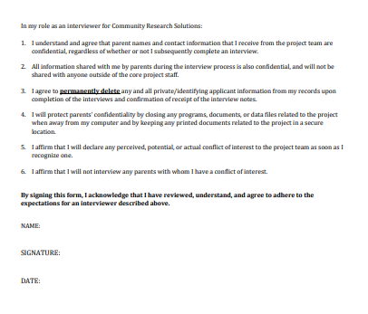

# Attachment 2: Suggested responses for handling respondent concerns

Occasionally, participants may express objections, complaints, or criticisms about participating in the interviews. It is important these issues be addressed promptly and accurately. *Objections, complaints, and criticism should be taken seriously.*

**We have no time to do this!**

If approximately 45 minutes is too long, the interview could be broken up in shorter sessions. While splitting up the interview is not ideal, it is preferrable to the family declining being interviewed.

**What is this all about anyway?**

We are interested how services can be delivered to families in the best possible way. We would like to talk to you to learn more about your experiences and opinions to be able to see if the way services are delivered may support your family, and how to make sure that we can continue these services in the future.

**Will the agency we worked get the information about us?**

No, everything you tell us is confidential; the agency staff will not be informed of what you or your child says.

**Are you connected to the police, court, IRS, welfare office, etc.?**

No, we work for the FRSS initiative. We do work that has to do with children and families. We are not connected to ________, and all the information we gather has no bearing on your involvement with ________.

**Who funds this research?**

The research funded by the Federal Government. [If the person wants more detail]: The specific agency that funds the evaluation is the Center for Mental Health Services of the Substance Abuse and Mental Health Services Administration.

**Will I be able to see the results?**

We write reports on our findings. These reports are public, but it will be quite a while before they are available. Of course, we will not discuss individual participants or families in these reports. No information you give will be able to be traced back to you.

**What will you do with the information?**

In the end, we hope to have a better understanding of the way services should be delivered to children in need of help with emotions and behaviors and what works the best. This may help parents, teachers, doctors, people working in the clinics, and policymakers in how to provide better services.

**Why do you want to pry into my life?**

We really don’t mean to pry. Your experience as a caregiver is valuable to us, and we would like to learn from you. That is why we need your help.

**I don’t want you to come to my home.**

That is no problem. We can meet online or by phone. If you want to meet in person, we can meet anywhere you suggest, like a library, community center, or coffee shop.

**It is not enough money.**

We know it is not much money and we are sorry we can’t offer you more. We realize you would have to sacrifice some time for this, but we would hope that you would be willing to help us anyway.

**Another relative says the caregiver does not want to do it.**

I respect that, but I would like to be able to talk to the caregiver personally. [It is important for us to understand what the reasons are for not wanting to do it.]

**I don’t want to answer some of the questions that you ask.**

Is there a specific reason why you do not wish to answer some questions? If so, I would like to reassure you that all the information that you give me is confidential and will **not** be shared with anyone outside the study. Also, the information you give us is coded and entered into the computer, so that your name is not used along with the answers you have given. These same questions are being asked of all the other parents who received services. [If this reassurance does not work, participants can be told that they may refuse to answer any question that they don’t feel comfortable answering.]

**Let me think about it and call you back.**

Participants should be kept engaged in the first contact. Instead of having them call back, see if you can identify a specific time for you to call them back. If the caregiver is hesitant in making a commitment, barriers and solutions to those barriers should be identified. Avoid getting no for an answer if possible.

# Attachment 3: Interviewer supplies

Prior to each interview, use the following checklist to make sure you have all items you may need.

Recommended materials for each interview

* Interview protocol
* Ink pens
* Paper for notes during the interview
* Post-its or other stickers to flag survey items

Additional forms

* Procedures for emergency disclosures (Attachment 5)
* Procedures for disclosures due to risk/threat of harm (Attachment 6)
* Procedure for filing grievances about services (Attachment 7)

Additional materials for in-person interviews

* Identification
* Map/directions to the family’s home/other meeting location
* Contact and address information

**NOTE:** You should only carry family contact information and other identifiable data with you if you will be conducting an in-person interview that day.

# Attachment 4: Skype instructions

1. **Sign into Skype at** [**https://www.skype.com/en/**](https://www.skype.com/en/)
2. **Click link to Use Skype online**

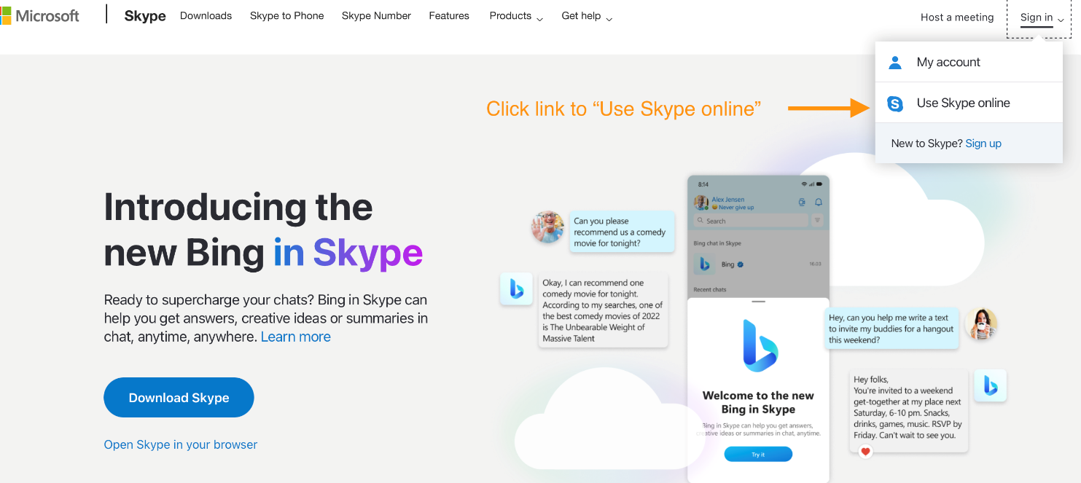

1. **Select “Meet Now”  followed by “Host a Meeting”**

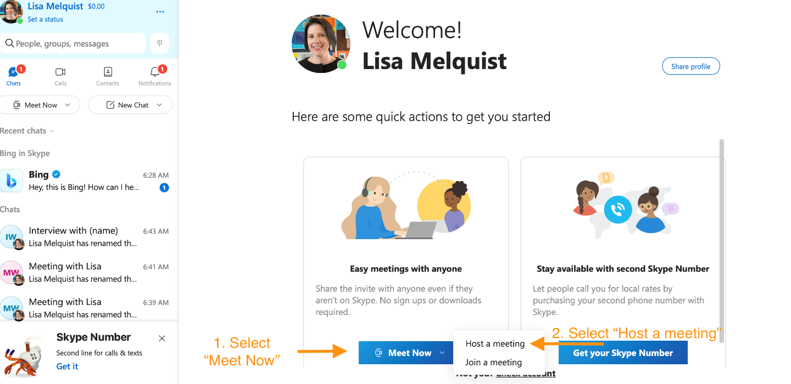

1. **You will now have a screen that gives a link that can be shared with others. First name the call, then select “Open chat.”**

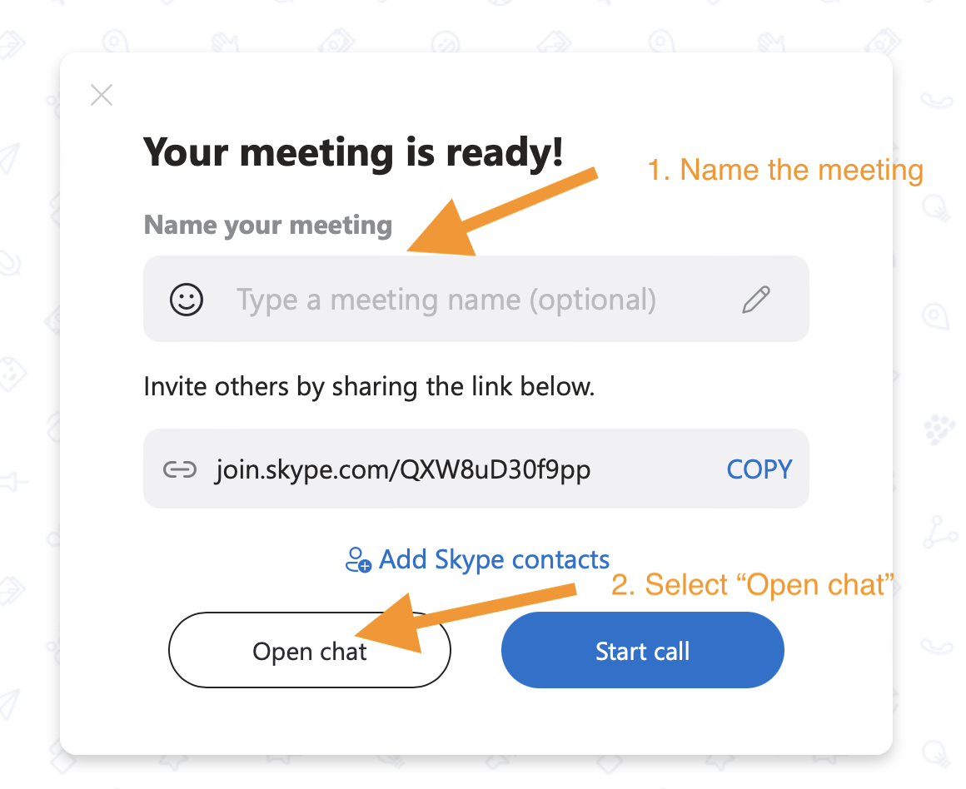

1. **Select “Add people”**

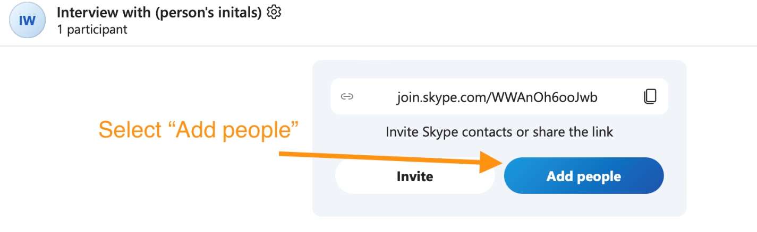

1. **Select “Share link to join group”**

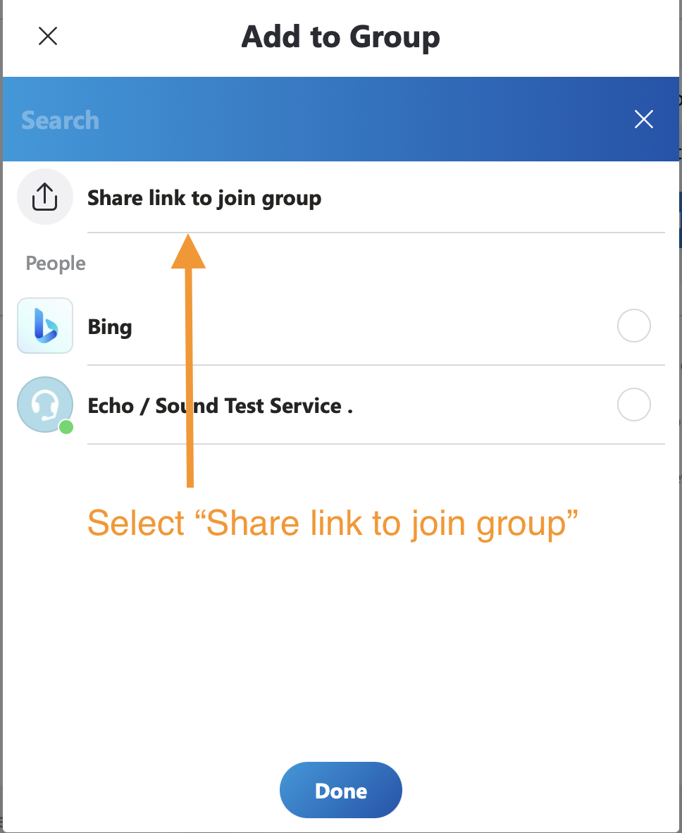

1. **Select “Copy link to clipboard”**

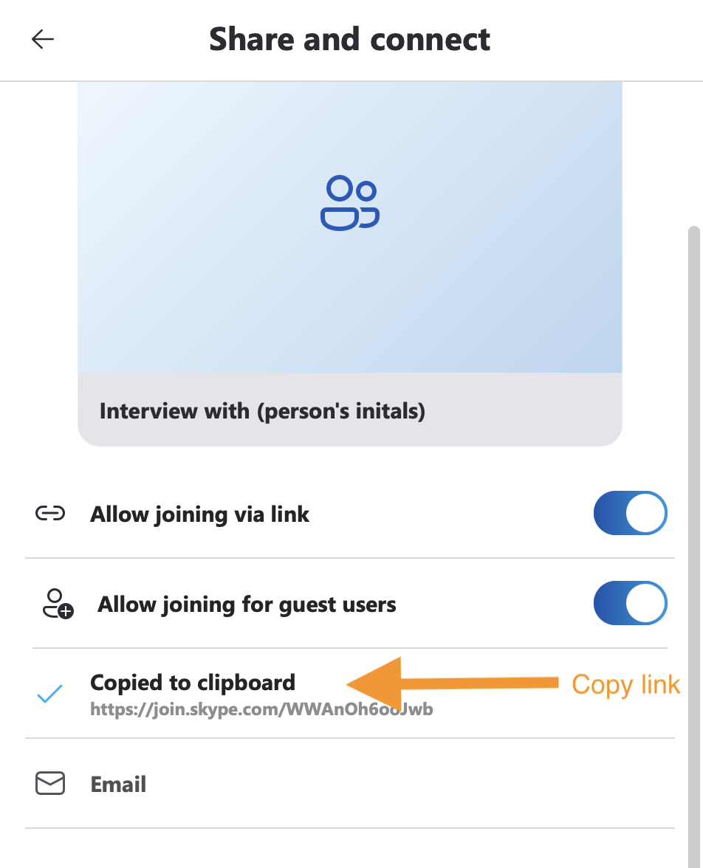

1. **Complete interview date and time details, then hit “Send.”**

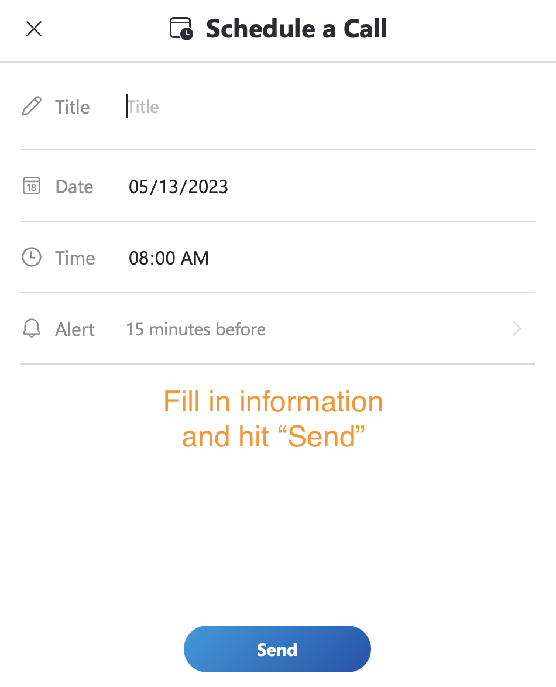

1. **Interview will then show on the main chat page.**

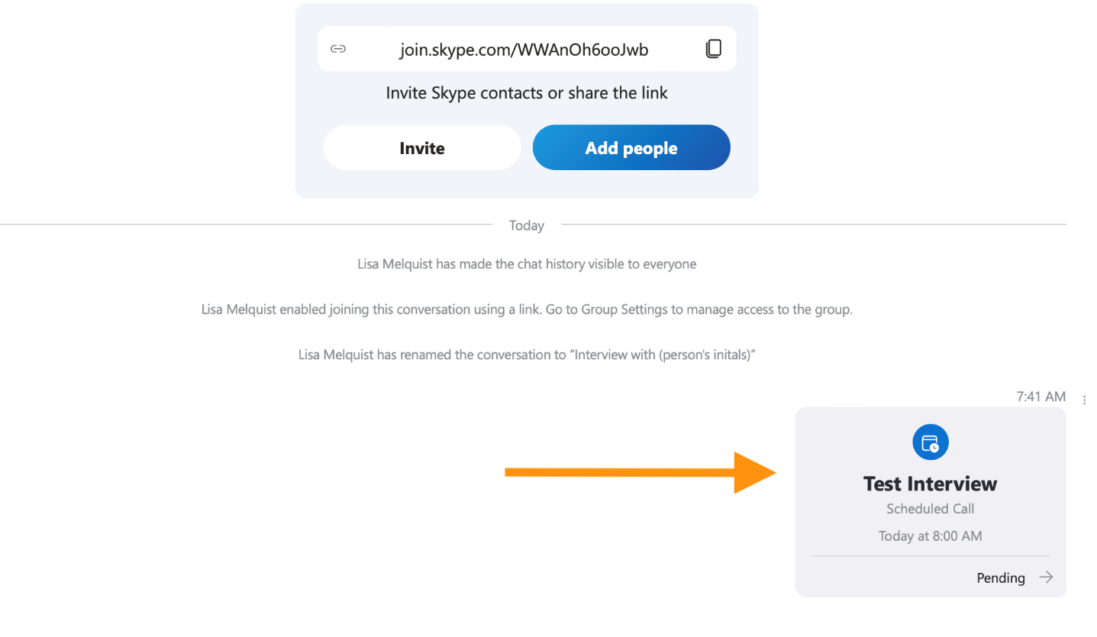

1. **Send link and interview meeting time to participant.**

# Attachment 5: Procedure for making emergency disclosures of confidential information

In the course of conducting evaluation activities, it is possible that evaluation team members will encounter emergency situations. For example, assistance may be required if someone is injured or needs immediate assistance in dealing with a crime or other emergency. In these situations, it is expected that evaluation staff will contact emergency personnel for assistance, even if this contact will require a disclosure of confidential information. It should be noted that emergency personnel should NOT be contacted if there is not an existing or imminent risk of harm. For instance, if an interviewer learns that abuse has occurred in the home situation some time ago, but is not taking place during or immediately prior to the interview, this would not be considered an emergency.

If an evaluation staff member encounters an individual who is in an emergency situation, the following procedure should be followed:

1. If evaluation staff are interacting with an individual who is an emergency situation that staff member should contact 911 immediately. This includes emergencies due to abuse, neglect, or domestic violence. The information provided to law enforcement regarding the situation should be limited to the minimum necessary to obtain assistance.

2. If a disclosure is made, the caregiver should be informed of the disclosure immediately, or as soon as it is appropriate.

3. If a staff person is not sure whether a call to 911 for a specific situation, they should contact Cheryl Holm-Hansen or Lisa Melquist.

4. If a disclosure is made, it should be reported immediately to Cheryl Holm-Hansen and Lisa Melquist.

# Attachment 6: Procedure for making disclosures of confidential information due to risk/threat of harm

During an interview or other contact with caregivers, it is possible that they will provide information suggesting that they are at risk of harming themselves, harming others, or being harmed by others. If you have concerns about these types of risks during an interview, complete this checklist and follow the recommendations at the end.

Child/youth name: _____________________________________ Youth ID: ____________

Interviewer name: _________________________________ Date of interview: ____________

Section 1: Suicidal ideation

|  |  |  |
| --- | --- | --- |
| 1. Was suicidal thinking or behavior reported during this interview\? | YES | NO  (skip to sec2) |
| 2. Did their responses to the interview indicate that they had these suicidal thoughts in the past, but do not currently feel suicidal? | YES | NO (skip to sec2) |
| 3. Are treatment providers aware of their suicidal thoughts or behaviors? (Ask if you are unsure) | YES | NO |
| 4. IF REPORTED BY A CHILD: Are caregivers aware of the child’s suicidal thoughts or behaviors? (Ask if you are unsure) | YES | NO |
| 5. Did you tell the caregiver/child that we might have to tell his/her treatment providers about this? | YES | NO |
| 6. Is the situation urgent (e.g., the participant currently appears very suicidal and treatment providers and caregivers are unaware of the situation?) | YES | NO |

Section 2: Physical or sexual abuse

|  |  |  |
| --- | --- | --- |
| 7. Was physical or sexual abuse observed during this interview? | YES | NO |
| 8. Was physical or sexual abuse reported during this interview? | YES | NO (skip to sec3) |
| 9. Are treatment providers aware of the physical or sexual abuse? (Ask if you are unsure) | YES | NO |
| 10. Has there been an official report made to anyone about the abuse (child protection, police, etc.)? | YES | NO |
| 11. IF REPORTED BY A CHILD: Are caregivers aware of the abuse? (Ask if you are unsure) | YES | NO |
| 12. Did you tell the caregiver/child that we might have to tell his/her treatment providers about this? | YES | NO |
| 13. Is the situation urgent (e.g., there is current unreported abuse reported by the child or caregiver or observed by you?) | YES | NO |

Section 3: Threats of harm to others

|  |  |  |
| --- | --- | --- |
| 14. Did the caregiver/child indicate a desire to hurt or cause physical harm to another person? | YES | NO (skip to sec4) |
| 15. Are treatment providers aware of their threats? (Ask if you are unsure) | YES | NO |
| 16. IF REPORTED BY A CHILD: Are caregivers aware of the child’s thoughts or behaviors? (Ask if you are unsure) | YES | NO |
| 17. Did you tell the caregiver/child that we might have to tell his/her treatment providers about this? | YES | NO |
| 18. Was a threat of harm made against a specific person? | YES | NO |

Section 4: Other

|  |  |  |
| --- | --- | --- |
| 19. Were there any other issues of immediate concern reported during the interview (e.g., fire setting, serious threats of violence either to the child or by the child)? | YES | NO (skip to end) |
| 20. Are treatment providers aware of this? (Ask if you are unsure) | YES | NO |
| 21. IF REPORTED BY A CHILD: Are caregivers aware of the child’s thoughts or behaviors or experiences? (Ask if you are unsure) | YES | NO |
| 22. Did you tell the child caregiver/child that we might have to tell his/her treatment providers about this? | YES | NO |
| 23. Is the situation urgent (e.g., fire setting that could cause damage or was intended to cause damage, specific and/or immediate threats of serious violence)? | YES | NO |

**If the answer to question 6, 13, 18 OR 23 is “YES”**

If there is evidence of a situation that may require urgent intervention, call or email Cheryl Holm-Hansen immediately after the interview. Cheryl can be reached at (612) 644-2463 or [evaluation@community-research.solutions](mailto:evaluation@community-research.solutions). If you cannot reach Cheryl, contact Lisa Melquist at (612) 760-2151 or [evaluation@community-research.solutions](mailto:evaluation@community-research.solutions). When you reach them, describe the situation and provide contact information for the family.

**Other situations requiring disclosure**

If the situation is not urgent, but you are worried about suicide, abuse, harm to others, or other situations, complete the above instructions within 24 hours after the interview.

# Attachment 7: Procedure for filing grievances about services

Occasionally, during an interview, a respondent may mention some concerns or grievances to an interviewer. If a respondent believes that a client has been neglected, abused, or otherwise mistreated during his/her service episode, the interviewer should complete this checklist. Some examples of situations that may warrant filing a grievance include:

* The respondent expresses concerns about bruises that have appeared following services
* The respondent feels that service is inadequate or failing to meet the client’s needs
* Behavior of staff person providing services appears to the respondent to be improper or suspicious

Evaluation staff are not responsible for investigating these claims, nor would it be appropriate to do so. If these experiences are reported, we can forward the claim to others within the system of care for follow-up, etc. If complaints are made, please complete the following checklist.

1. Is the caregiver willing to make a complaint directly to the agency/program staff?

___ NO (Go to question 2)

___ YES (Encourage them to contact program staff; no further action necessary)

2. Is the caregiver willing to make a complaint directly to the project director, Asad Dahir?

___ NO (Go to question 3)

___ YES (Encourage them to contact the project director and provide his contact information; no further action necessary)

3. Is the caregiver willing to waive their right to confidentiality so that we can file a grievance on their behalf?

___ NO (No further action necessary)

___ YES (Complete remainder of this form)

**Description of complaint**

Agency/program: ______________________________________________________________

Specific staff person (if known): ___________________________________________________

Child/youth name: _____________________________________________________________

Caregiver name: ______________________________________________________________

Contact information for parent: ______________________________

Nature of complaint

Signature of person conducting interview Today’s date