Family Response evaluation procedures
2/27/23

For our evaluation of the SAMHSA Children’s Mental Health Initiative grant to Hennepin County, we will collect some basic information about the youth and families served through the Family Response program. This information will be used to satisfy county reporting requirements along with providing vital information about the implementation and success of the Family Response and Stabilization Service approach.

Evaluation requirements for Family Response fall into two categories:

1
Collect and submit client service documentation, including Crisis Assessment Tools and safety plans

First, we will collect documentation for each youth/family served through the Family Response program. Documentation will include records maintained by Family Response staff between referral and discharge, along with results from the Crisis Assessment Tool and a copy of the safety plan completed for each youth/family.

The provision of this individual and identifiable data is protected under a signed Business Associate Agreement between Nexus-FACTs and Community Research Solutions. Individual but de-identified data will also be submitted to Hennepin County on a monthly basis by the evaluation team. This data submission will fulfill the county contracting reporting requirements.

Information needed

Basic information will be collected for each family served through the Family Response program. This information will include client identifiers, information about the initial referral call, a summary of the initial family response, family demographic information, and a summary of the family discharge status. See Attachment 1 for detailed data dictionary. In addition to this service information, a completed Crisis Assessment Tool (see attachment 2) and safety plan should be submitted for each client.

Information submission

Timeline. An Excel file including all service documentation should be provided to the evaluation team on a monthly basis. Data should be submitted by the 5th of each month (or the next business day if this falls on a weekend), covering all data collected during the two-month window noted below. Note that youth may appear in submissions for two consecutive months (i.e., youth served in July will be included in the data submitted in August and September. Data will be unduplicated by the evaluation team. If the file does not include Crisis Assessment Tool results and/or service plans, those materials can be submitted separately and only need to be submitted once per youth/family.

Submission month | Period covered | Submission month | Period covered
January | November-December | July | May-June
February | December-January | August | June-July
March | January-February | September | July-August
April | February-March | October | August-September
May | March-April | November | September-October
June | April-May | December | October-November

Submission instructions: There are multiple options for submitting information, which can be used in combination as desired.

Client service documentation: An encrypted/password protected excel file should be submitted monthly. The file can either be emailed electronically to evaluation@community-research.solutions, or uploaded here.

Crisis assessment tool: Complete responses to the Crisis Assessment Tool should be submitted for each client. There are two options for submitting these results.

Option 1: Enter data into the same excel file that is completed for the service data, and send an updated file monthly.

Option 2: Scan each Crisis Assessment Tool and upload them individually here. If submitted outside of the monthly excel file, the completed Crisis Assessment Tool only needs to be submitted once for each youth/family served.

Option 3: Manually enter the data for each Crisis Assessment Tool as they are completed.

Safety plan: A copy of the completed safety plan should be submitted for each client. There are two options for submitting these results.

Option 1: Enter data into the same excel file that is completed for the service data, and send an updated file monthly.

Option 2: Scan each safety plan (or take a photo) and upload them individually here. If submitted outside of the monthly excel file, the completed safety plan only needs to be submitted once for each youth/family served.

Collect 30-day follow-up feedback
2

Feedback from families should be collected 30-days post discharge. Project staff can collect the information from each family using a variety of approaches based on convenience to staff and the family. Surveys can be completed via email or text, or completed over the phone. If desired, the evaluation team can set up an online form for families to submit responses directly.

Information needed

See attachment 3 for 30-day follow-up questions.

Information submission

All completed 30-day follow-ups should be submitted to the evaluation team as completed or at least on a monthly basis. If included in the excel file with the discharge data, responses should be submitted by the 5th of each month, covering the same time periods as noted above. Responses can also be submitted individually as they are completed. There are multiple options for submitting information:

Option 1: Enter data into the same excel file that is completed for the service data, and send an updated file monthly.

Option 2: Complete the 30-day follow-up survey using the fillable form and upload them individually here. If submitted outside of the monthly excel file, the completed 30-day follow-up survey only needs to be submitted once for each youth/family served.

Option 3: Manually enter the data for each 30-day follow-up as they are completed.

Attachment 1: Client service tracking

Variable | Content
Youth name | Text field with first and last name
ID number * | Case number assigned by Family Response provider at the time of referral
Initial referral call
Referral call date * | Date of initial referral call
Referral call time * | Time initial call ended
Parent consent | Parent consented to the referral call: yes/no/unknown
Referral type | Initial referral source: child protection, parent/caregiver, hospital, school, county case manager, case manager – other, medical personnel (non-hospital), parent support specialist – Hennepin County  NOTE: Additional sources can be added as needed.
Referring hospital name | Drop down menu of referring hospital names (leave blank if referral did not come from a hospital)
Referral school name | Text field with name of referring school (no drop down due to large potential number of schools and challenges keeping list current) (leave blank of referral did not come from a school)
Call reason | Reasons for family response referral (choose all that apply): aggression, anxiety, depression, domestic violence, drug use, family conflict, illegal behavior, parent/caregiver behavior, physical abuse, runaway, school issues, self-harm, significant oppositional behavior, suicidality, truancy, weapons, and other.  NOTE: Additional reasons can be added as needed. Responses should be separated into separate variables, with only one response per cell.
Received services before* | Family has previously received Family Response services: yes (repeat family)/no (new family)
Meets service criteria | Family meets enrollment criteria (child age 5-18 and Hennepin County residents): yes/no
Response | Type of response: dispatched family response staff, community services, parent/caregiver refused services, formal placement, behavioral health services, family did not respond, hospital, hospital ER, scheduled future meeting  NOTE: Responses should be separated into separate variables, with only one response per cell. Additional options can be added as needed.
Initial family meeting
Date of initial family meeting
Time of initial family meeting
Contact medium | Contact medium for initial family meeting: did not meet, face-to-face, telephone, video conference  NOTE: Additional options can be added as needed.
Response at family’s chosen time/medium * | The initial time and medium for family meeting aligned with family preference: Yes/no/unknown
If not at preferred time/method, why not? | Text field indicating what could not be accommodated and why (only if response to previous question was “no”)
Reason declined | Text field indicating why family does not want FR services (only if previous field was “parent/caregiver refused services)
Reason for delay * | Primary reason if response was more than one hour from the initial call: caregiver delayed, outside of office hours, weather, staff capacity, language needs.  NOTE: Additional reasons can be added as needed
Clients
Youth birthdate

Youth age | Youth age at time of intake
Youth race* | Youth race: Black or African American, White, Native American, Hispanic or Latino, Asian, Biracial or multiracial, Not identified
Parent/guardian 1 race | Parent race(s) – check all that apply: Black or African American, White, Native American, Hispanic or Latino, Asian, Biracial or multiracial, Not identified, not applicable
Parent/guardian 2 race | Parent race(s) – check all that apply: Black or African American, White, Native American, Hispanic or Latino, Asian, Biracial or multiracial, Not identified, not applicable
Youth gender* | Youth gender: female, male, transgender male, transgender female, non-binary/gender-fluid/agender
City | City of residence (text field)
Family living arrangement | Living arrangement: youth living with relatives (not biological parent), youth living with both biological parents, youth living with one biological parent, youth living with legal guardian, youth living with foster family
Homeless | Family currently homeless: yes/no
School | Name of school youth attends (text field)  NOTE: This may be the same as the referring school but should be provided anyway.
Discharge
Discharge date | Date of discharge
Referred to | Referred to: community organization, hospital, medical personnel (non-hospital), care coordinator, behavioral health provider, county case manager, case manager-other, child protection, law enforcement  NOTE: Referrals should be separated into separate variables, with only one response per cell. More than one option can be selected.
Wraparound * | A referral was made for wraparound services: yes/no
Targeted case management * | A referral was made for targeted case management: yes/no
Stabilization services* | A referral was made for stabilization services: yes/no
Stabilization provider | Agency receiving the referral for stabilization services (only if stabilization services were indicated above)
ER visits | Youth went to an Emergency Department for behavioral or mental health while they were in Family Response: yes/no
Law enforcement | Youth had interactions with law enforcement while they were in Family Response: yes/no
Out of home placement | Youth went into an out-of-home placement while they were in Family Response: yes/no
Changes in living arrangement | Other than out-of-home placements, youth’s living situation changed while they were in Family Response: yes/no
Insurance status | Family insurance status (check all that apply) – Family is uninsured; Family has public insurance (MA/PMAP); Family has private insurance
Insurance provider | If family has private insurance, provider name (i.e., Health Partners, Blue Cross/Blue Shield, etc.).

* Individual but de-identified will be submitted to Hennepin County on a monthly basis by the evaluation team. This data submission will fulfill the county contracting reporting requirements.

Attachment 2: Crisis Assessment Tool
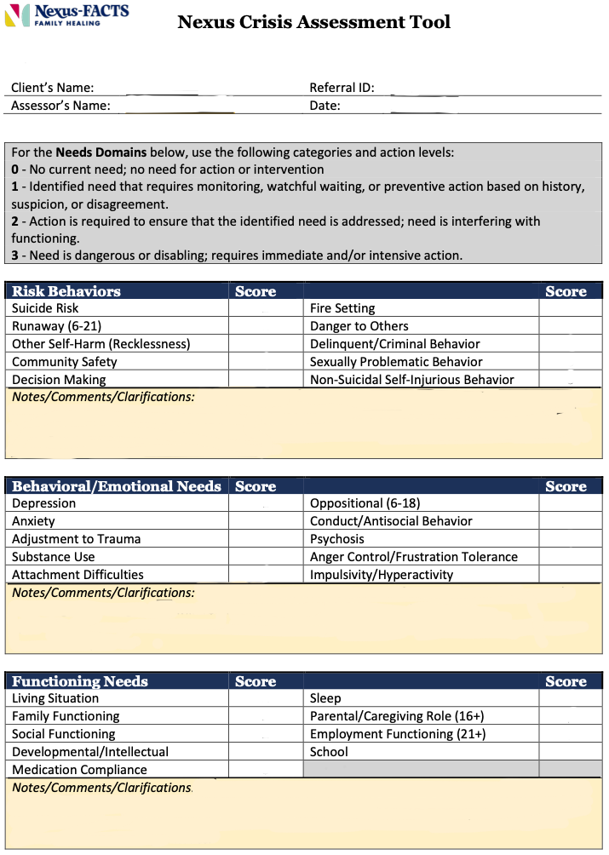

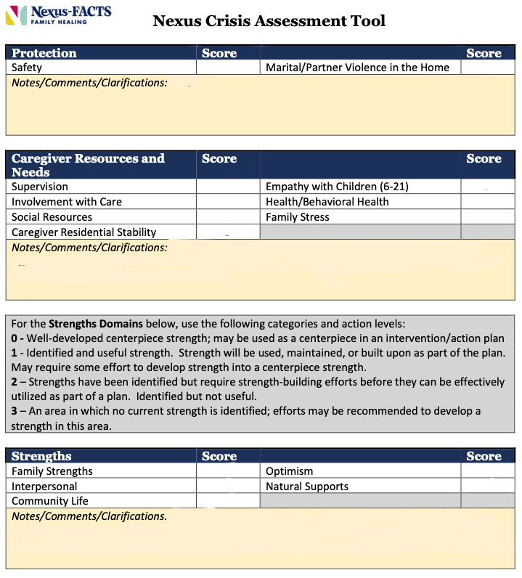
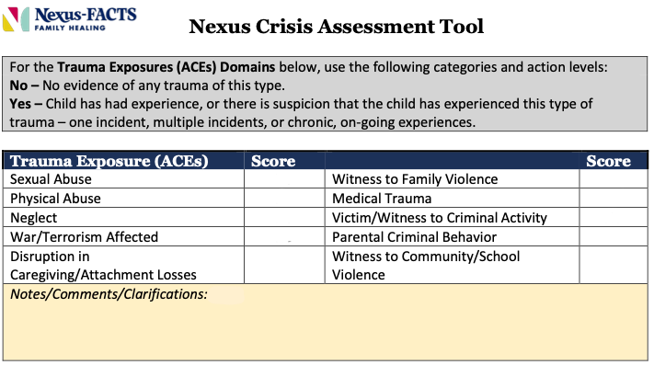
Attachment 3: 30-day follow-up survey
(SAMPLE – PLEASE USE STANDALONE VERSION)

Youth name: Click or tap here to enter text.

Youth ID: Click or tap here to enter text.

Youth date of birth: Click or tap to enter a date.

Agency providing Family Response Services: Click or tap here to enter text.

Date follow-up completed: Click or tap to enter a date.

 | Strongly agree | Agree | Disagree | Strongly disagree | Not applicable
1. I was able to connect with Family Response at a time that was easy and convenient for me. | ☐ | ☐ | ☐ | ☐ | ☐
2. The Family Response staff responded in a way that was appropriate to my gender, language, cultural and spiritual needs. | ☐ | ☐ | ☐ | ☐ | ☐
3. Family Response services worked with me in a way to create plans for support and stability. | ☐ | ☐ | ☐ | ☐ | ☐
4. Overall, I feel hopeful that the plans will meet my family needs. | ☐ | ☐ | ☐ | ☐ | ☐
5. I am satisfied about the Family Response services we received. | ☐ | ☐ | ☐ | ☐ | ☐
6. I would recommend Family Response to other families with a similar need. | ☐ | ☐ | ☐ | ☐ | ☐

7. What is the living arrangement of the youth for which you sought Family Response services?
☐ Both biological parents
☐ Biological mother
☐ Biological father
☐ Other relatives
☐ Legal guardian who is not a relative
☐ Foster parents
☐ Other (please specify: Click or tap here to enter text.)

8. Has the youth had any out-of-home placements since you completed Family Response services? *
☐ No
☐ Yes

9. Other than out-of-home placements, is the youth’s living situation different from when you called Family Response? *
☐ No
☐ Yes: why has the living arrangement changed? Click or tap here to enter text.

10. Have you needed to go to an Emergency Department for your child’s behavioral or mental health since your family finished Family Response?*
☐ No
☐ Yes

11. Have you or your child had any interactions with law enforcement regarding your child’s behavior since your family finished Family Response?*
☐ No
☐ Yes

12. Has your family received mental health services for which you were referred?*
☐ No (why not? Click or tap here to enter text.)
☐ Yes
☐ Not applicable

13. Has your family received other services or supports for which you were referred, such as cultural, religious, or other community organizations?*
☐ No (why not? Click or tap here to enter text.)
☐ Yes
☐ Not applicable

14. Name of Family Response provider you worked with (optional): Click or tap here to enter text.

15. Any feedback you’d like to provide us? Click or tap here to enter text.

* Individual but de-identified will be submitted to Hennepin County on a monthly basis by the evaluation team. This data submission will fulfill the county contracting reporting requirements.

